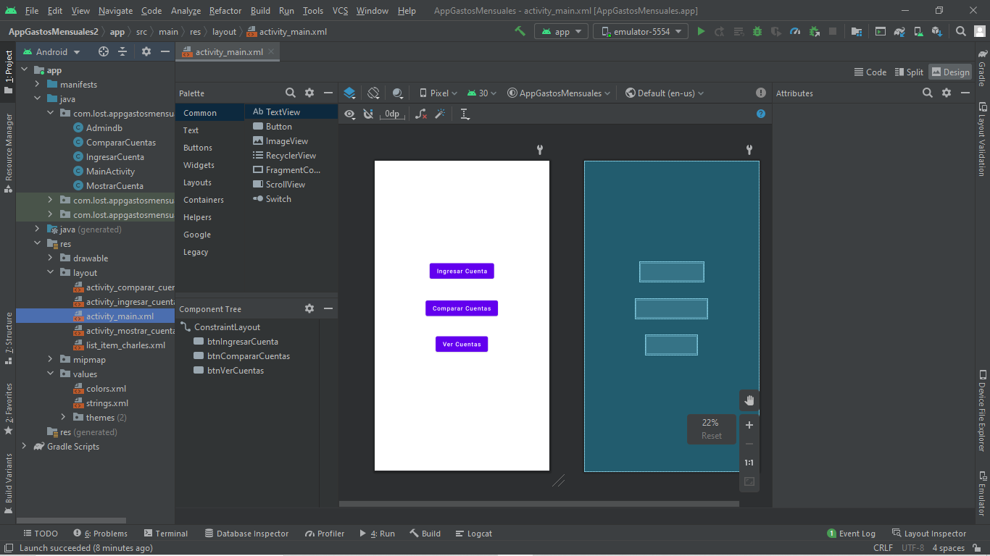
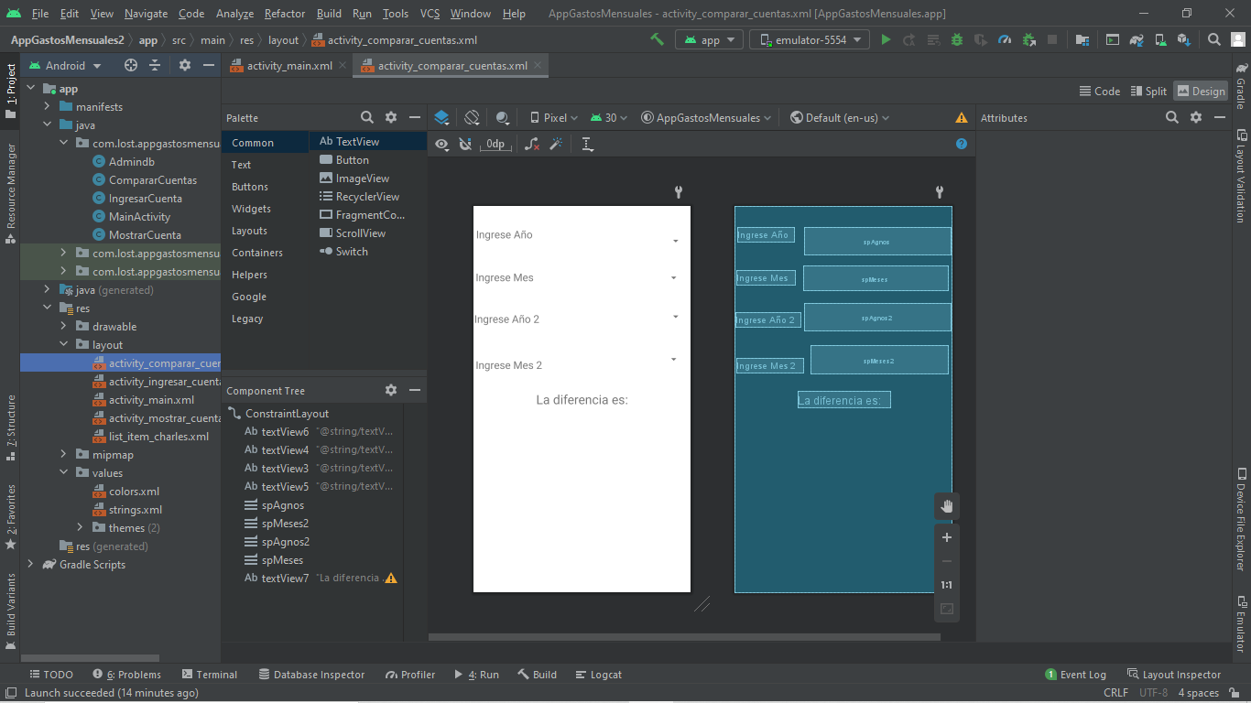
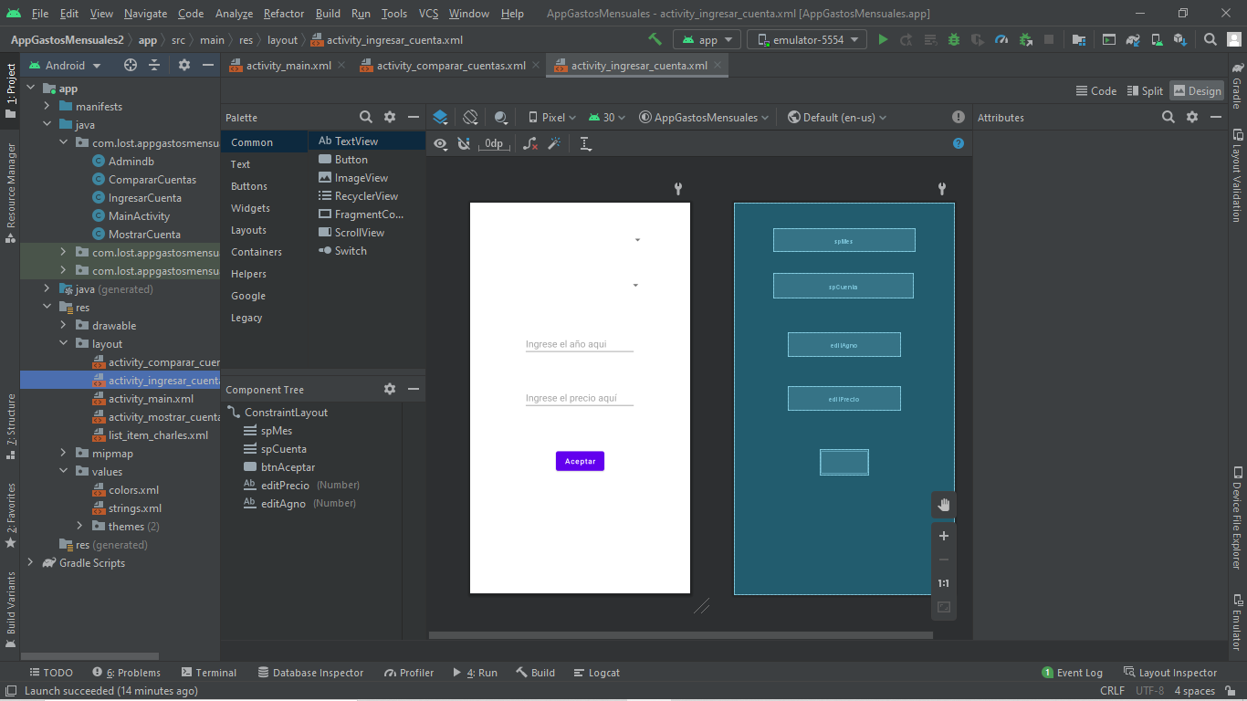
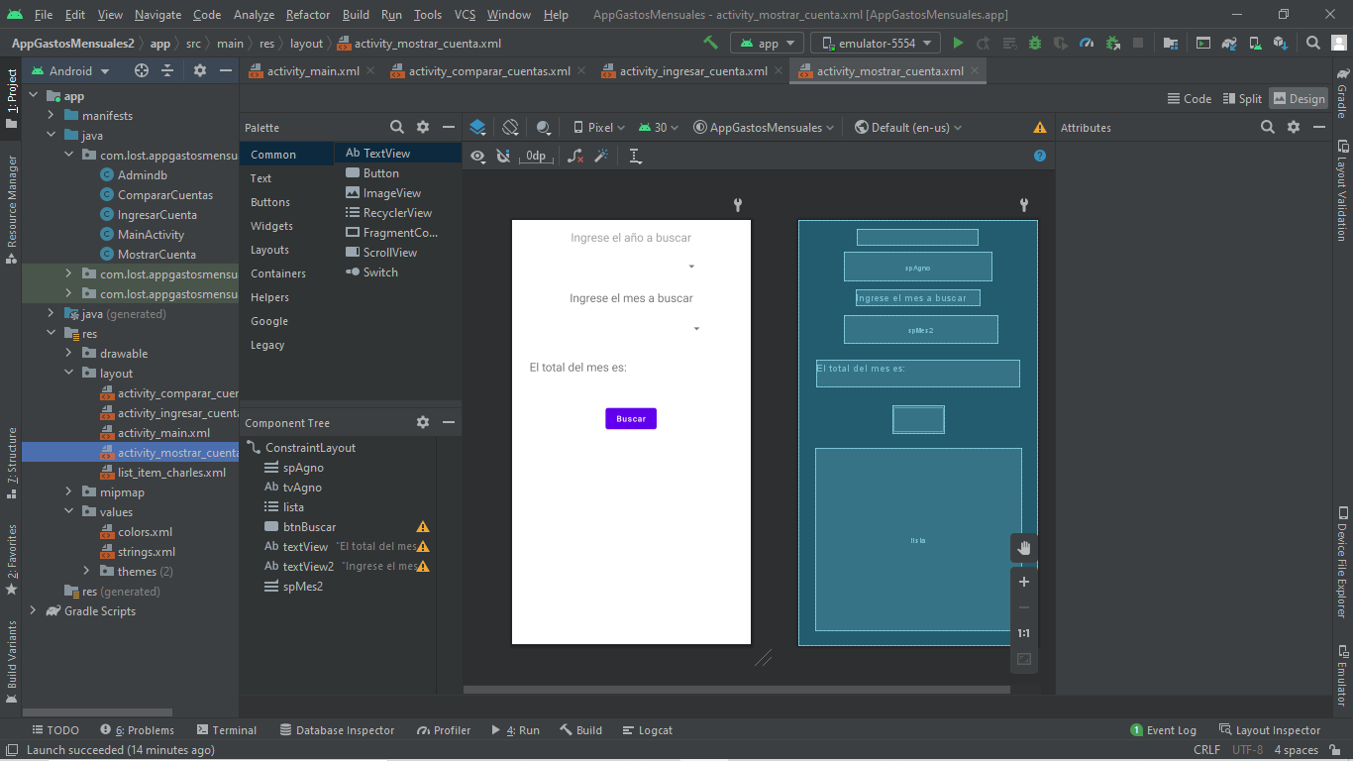

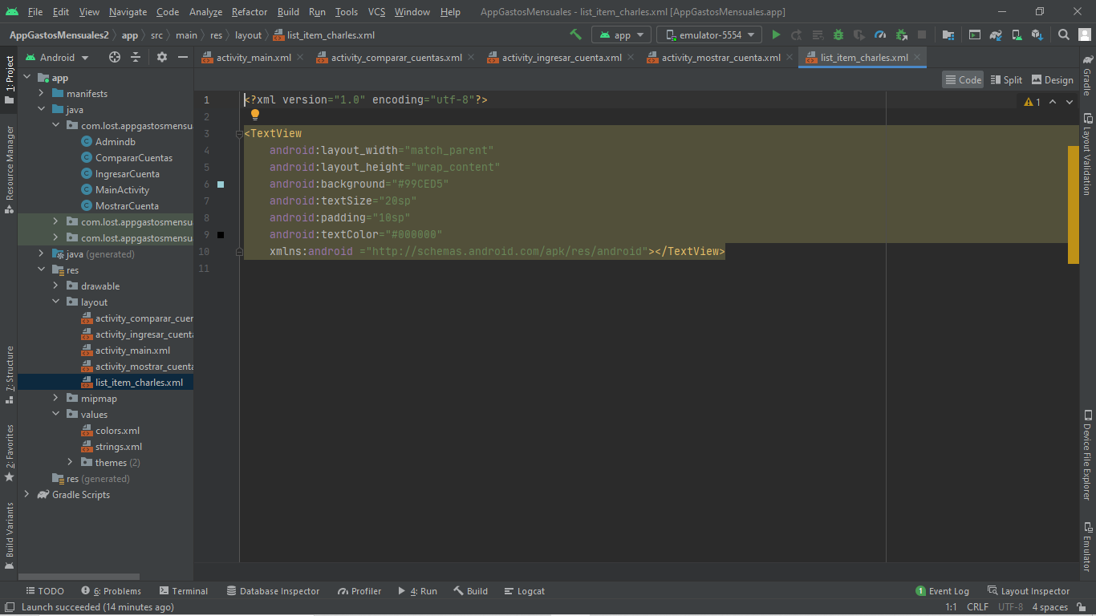

//CODIGO
package com.lost.appgastosmensuales;
import android.content.Context;
import android.database.sqlite.SQLiteDatabase;
import android.database.sqlite.SQLiteOpenHelper;
import androidx.annotation.Nullable;
public class Admindb extends SQLiteOpenHelper {
public Admindb(@Nullable Context context, @Nullable String name, @Nullable SQLiteDatabase.CursorFactory factory, int version) {
super(context, name, factory, version);
}
@Override
public void onCreate(SQLiteDatabase db) {
db.execSQL("create table Meses(" +
"nombre varchar)");
db.execSQL("create table Cuentas(" +
"nombre varchar)");
db.execSQL("create table PagoCuentas(" +
"mes int," +
"agno int," +
"precio int," +
"cuenta int," +
"foreign key (cuenta) references Cuentas(rowid))");
}
@Override
public void onUpgrade(SQLiteDatabase db, int oldVersion, int newVersion) {
}
}

package com.lost.appgastosmensuales;
import androidx.appcompat.app.AppCompatActivity;
import android.database.Cursor;
import android.database.sqlite.SQLiteDatabase;
import android.os.Bundle;
import android.widget.ArrayAdapter;
import android.widget.Spinner;
import java.util.ArrayList;
public class CompararCuentas extends AppCompatActivity {
private Spinner spAgno, spMes;
private Admindb admin;
private SQLiteDatabase base;
@Override
protected void onCreate(Bundle savedInstanceState) {
super.onCreate(savedInstanceState);
setContentView(R.layout.activity_comparar_cuentas);
spAgno = findViewById(R.id.spAgnos2);
spMes = findViewById(R.id.spMes2);
mostrarAgnos();
}
private void mostrarAgnos(){
admin = new Admindb(this, MainActivity.nombreBaseDatos, null,1);
base = admin.getReadableDatabase();
ArrayList<String> arreglo = new ArrayList<>();
Cursor fila = base.rawQuery("select agno from PagoCuentas group by agno order by agno", null );
while(fila.moveToNext()){
arreglo.add(fila.getString(0));
}
ArrayAdapter<String> adapter = new ArrayAdapter<>(this, android.R.layout.simple_spinner_item, arreglo);
adapter.setDropDownViewResource(android.R.layout.simple_spinner_dropdown_item);
spAgno.setAdapter(adapter);
}
}

package com.lost.appgastosmensuales;
import androidx.appcompat.app.AppCompatActivity;
import android.content.ContentValues;
import android.database.Cursor;
import android.database.sqlite.SQLiteDatabase;
import android.os.Bundle;
import android.view.View;
import android.widget.ArrayAdapter;
import android.widget.EditText;
import android.widget.Spinner;
import android.widget.Toast;
import java.util.ArrayList;
public class IngresarCuenta extends AppCompatActivity {
private Admindb admin;
private SQLiteDatabase base;
private Spinner spinner;
private Spinner spinner2;
private EditText agno, precio;
@Override
protected void onCreate(Bundle savedInstanceState) {
super.onCreate(savedInstanceState);
setContentView(R.layout.activity_ingresar_cuenta);
agno = findViewById(R.id.editAgno);
precio = findViewById(R.id.editPrecio);
spinner = findViewById(R.id.spMes);
obtenerMes();
spinner2 = findViewById(R.id.spCuenta);
obtenerCuenta();
}
private void obtenerMes(){
admin = new Admindb(this, MainActivity.nombreBaseDatos, null, 1);
base = admin.getReadableDatabase();
Cursor cursor = base.rawQuery("select rowid, nombre from Meses", null);
ArrayList<String> arreglo = new ArrayList<>();
while(cursor.moveToNext()){
arreglo.add(cursor.getInt(0) + " - " + cursor.getString(1));
}
ArrayAdapter<String> adapter = new ArrayAdapter<String>(this, android.R.layout.simple_spinner_item, arreglo);
adapter.setDropDownViewResource(android.R.layout.simple_spinner_dropdown_item);
spinner.setAdapter(adapter);
}
private void obtenerCuenta(){
admin = new Admindb(this, MainActivity.nombreBaseDatos, null, 1);
base = admin.getReadableDatabase();
Cursor cursor = base.rawQuery("select rowid, nombre from Cuentas", null);
ArrayList<String>arreglo = new ArrayList<>();
while(cursor.moveToNext()){
arreglo.add(cursor.getInt(0)+ " - " + cursor.getString(1));
}
ArrayAdapter<String> adapter = new ArrayAdapter<>(this, android.R.layout.simple_spinner_item, arreglo);
adapter.setDropDownViewResource(android.R.layout.simple_spinner_dropdown_item);
spinner2.setAdapter(adapter);
}
public void ingresarCuenta(View view) {
admin = new Admindb(this, MainActivity.nombreBaseDatos, null, 1);
base = admin.getWritableDatabase();
ContentValues values = new ContentValues();
long selected = spinner.getSelectedItemId() + 1;
long selectedCta = spinner2.getSelectedItemId() + 1;
if (agno.getText().toString().isEmpty()) {
Toast.makeText(this, "Debe ingresar un año valido", Toast.LENGTH_LONG).show();
}
else if(precio.getText().toString().isEmpty()){
Toast.makeText(this, "Debe ingresar un precio valido", Toast.LENGTH_LONG).show();
}
else {
values.put("mes", selected);
values.put("agno", agno.getText().toString());
values.put("precio", precio.getText().toString());
values.put("cuenta", selectedCta);
base.insert("PagoCuentas", null, values);
base.close();
Toast.makeText(this, "Cuenta ingresada correctamente", Toast.LENGTH_LONG).show();
spinner.setSelection(0);
spinner2.setSelection(0);
agno.setText(null);
precio.setText(null);
}
}
}

package com.lost.appgastosmensuales;
import androidx.appcompat.app.AppCompatActivity;
import android.content.ContentValues;
import android.content.Intent;
import android.database.sqlite.SQLiteDatabase;
import android.os.Bundle;
import android.view.View;
public class MainActivity extends AppCompatActivity {
private Admindb admin;
private SQLiteDatabase base;
public static final String nombreBaseDatos = "PagoCuentas3.2";
@Override
protected void onCreate(Bundle savedInstanceState) {
super.onCreate(savedInstanceState);
setContentView(R.layout.activity_main);
admin = new Admindb(this, nombreBaseDatos, null, 1);
base = admin.getWritableDatabase();
base.delete("Meses","", null);
rellenoMeses(base);
base.delete("Cuentas", "", null);
rellenoCuentas(base);
base.close();
}
private void rellenoMeses(SQLiteDatabase base){
ContentValues values = new ContentValues();
values.put("nombre", "Enero");
base.insert("Meses", null, values);
values.clear();
values.put("nombre", "Febrero");
base.insert("Meses", null, values);
values.clear();
values.put("nombre", "Marzo");
base.insert("Meses", null, values);
values.clear();
values.put("nombre", "Abril");
base.insert("Meses", null, values);
values.clear();
values.put("nombre", "Mayo");
base.insert("Meses", null, values);
values.clear();
values.put("nombre", "Junio");
base.insert("Meses", null, values);
values.clear();
values.put("nombre", "Julio");
base.insert("Meses", null, values);
values.clear();
values.put("nombre", "Agosto");
base.insert("Meses", null, values);
values.clear();
values.put("nombre", "Septiembre");
base.insert("Meses", null, values);
values.clear();
values.put("nombre", "Octubre");
base.insert("Meses", null, values);
values.clear();
values.put("nombre", "Noviembre");
base.insert("Meses", null, values);
values.clear();
values.put("nombre", "Diciembre");
base.insert("Meses", null, values);
values.clear();
}
private void rellenoCuentas(SQLiteDatabase base){
ContentValues values = new ContentValues();
values.put("nombre", "Cuenta de Luz");
base.insert("Cuentas", null, values);
values.clear();
values.put("nombre", "Cuenta de Agua");
base.insert("Cuentas", null, values);
values.clear();
values.put("nombre", "Cuenta de Gas");
base.insert("Cuentas", null, values);
values.clear();
values.put("nombre", "Cuenta de Internet");
base.insert("Cuentas", null, values);
values.clear();
}
public void ingresarCuenta(View view){
Intent intent = new Intent(this, IngresarCuenta.class);
startActivity(intent);
}
public void verCuenta(View view){
Intent intent = new Intent(this, MostrarCuenta.class);
startActivity(intent);
}
public void compararCuenta(View view){
Intent intent = new Intent(this, CompararCuentas.class);
startActivity(intent);
}
}

package com.lost.appgastosmensuales;
import androidx.appcompat.app.AppCompatActivity;
import android.database.Cursor;
import android.database.sqlite.SQLiteDatabase;
import android.os.Bundle;
import android.view.View;
import android.widget.ArrayAdapter;
import android.widget.ListView;
import android.widget.Spinner;
import android.widget.TextView;
import android.widget.Toast;
import java.util.ArrayList;
public class MostrarCuenta extends AppCompatActivity {
private Admindb admin;
private SQLiteDatabase base;
private Spinner spAgno, spMes;
private ListView lv1;
private TextView tv1;
@Override
protected void onCreate(Bundle savedInstanceState) {
super.onCreate(savedInstanceState);
setContentView(R.layout.activity_mostrar_cuenta);
spAgno = findViewById(R.id.spAgno);
spMes = findViewById(R.id.spMes2);
lv1 = findViewById(R.id.lista);
tv1 = findViewById(R.id.textView);
mostrarAgnos();
mostrarMeses();
}
private void mostrarAgnos(){
admin = new Admindb(this, MainActivity.nombreBaseDatos, null,1);
base = admin.getReadableDatabase();
ArrayList<String> arreglo = new ArrayList<>();
Cursor fila = base.rawQuery("select agno from PagoCuentas group by agno order by agno", null );
while(fila.moveToNext()){
arreglo.add(fila.getString(0));
}
ArrayAdapter<String> adapter = new ArrayAdapter<>(this, android.R.layout.simple_spinner_item, arreglo);
adapter.setDropDownViewResource(android.R.layout.simple_spinner_dropdown_item);
spAgno.setAdapter(adapter);
}
private void mostrarMeses(){
admin = new Admindb(this, MainActivity.nombreBaseDatos, null,1);
base = admin.getReadableDatabase();
ArrayList<String> arreglo = new ArrayList<>();
Cursor fila = base.rawQuery("select m.nombre " +
"from Meses as m ", null );
while(fila.moveToNext()){
arreglo.add(fila.getString(0));
}
ArrayAdapter<String> adapter = new ArrayAdapter<>(this, android.R.layout.simple_spinner_item, arreglo);
adapter.setDropDownViewResource(android.R.layout.simple_spinner_dropdown_item);
spMes.setAdapter(adapter);
}
public void mostrarElementos(View view){
admin = new Admindb(this, MainActivity.nombreBaseDatos, null,1);
base = admin.getReadableDatabase();
String agno = spAgno.getSelectedItem().toString();
String mes = spMes.getSelectedItem().toString();
int suma = 0;
Cursor fila = base.rawQuery("select m.nombre, pc.agno, pc.precio, pc.cuenta, c.nombre " +
"from PagoCuentas as pc "+
"inner join Cuentas as c "+
"ON pc.cuenta = c.rowid "+
"and agno = " + agno +
" inner join Meses as m "+
"On pc.mes = m.rowid", null);
ArrayList<String> arreglo = new ArrayList<>();
while(fila.moveToNext()){
if(mes.equals(fila.getString(0))){
arreglo.add(fila.getString(4) + " | " + fila.getString(0) + " | " + fila.getInt(2));
suma += fila.getInt(2);
}
}
ArrayAdapter<String> adapter = new ArrayAdapter<>(this, R.layout.list_item_charles, arreglo);
lv1.setAdapter(adapter);
tv1.setText("El total del mes es: " + suma);
}
}

